**Login as a Sport Officer**

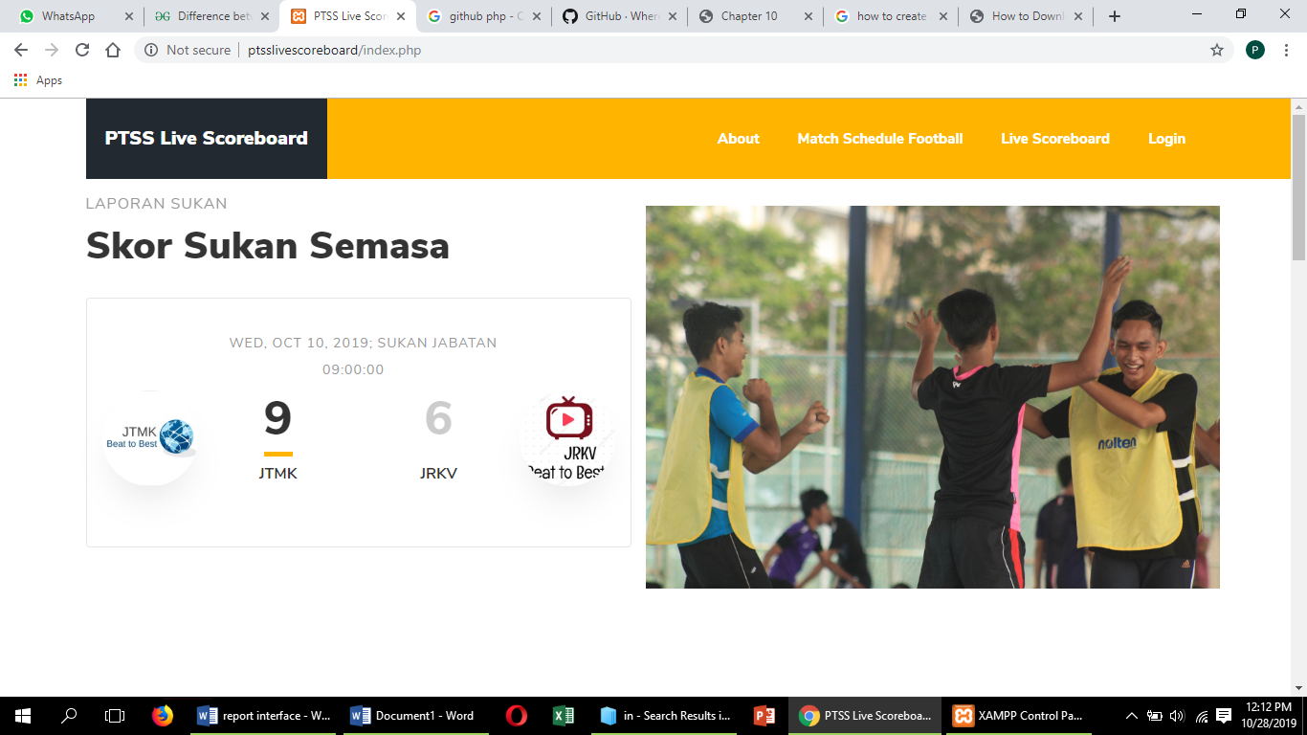

Figure 1 Page home

This is page home before user click login.

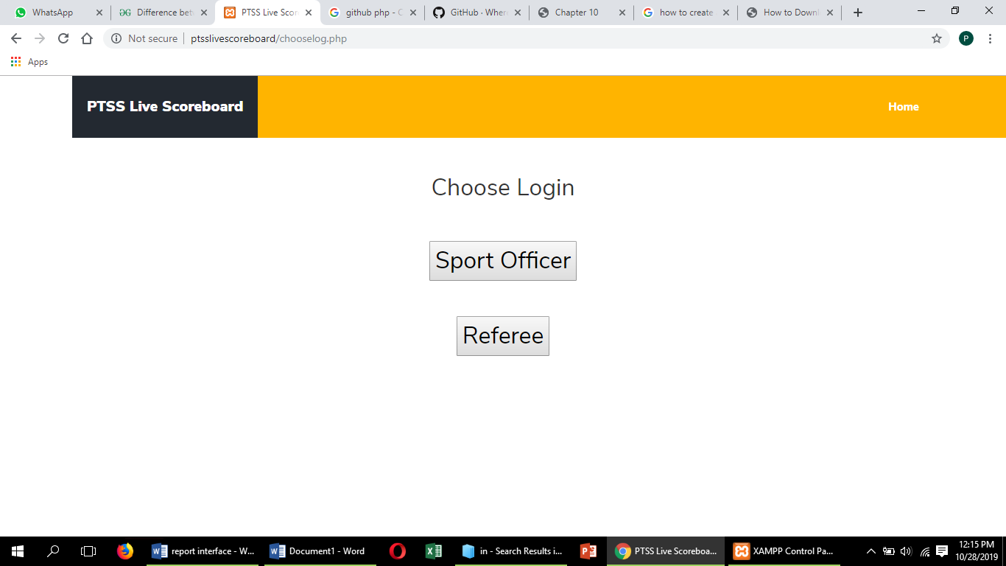

Figure 2 Login as a sport officer

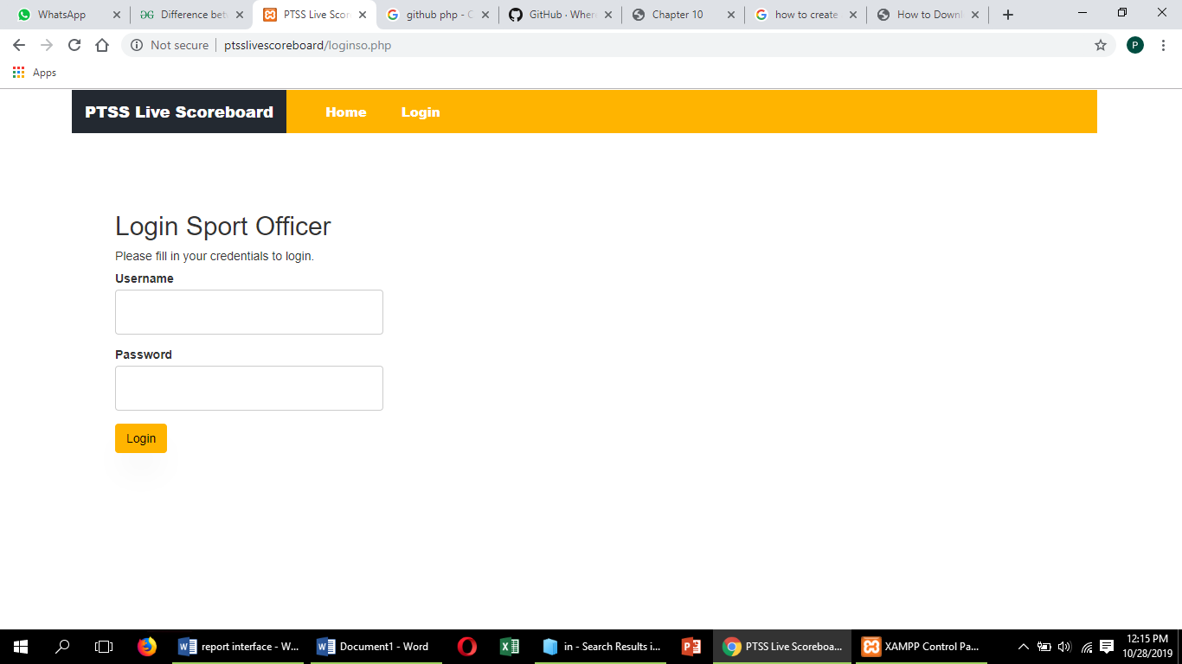

Figure 3 Page login sport officer

Page login sport officer after click sport officer button.

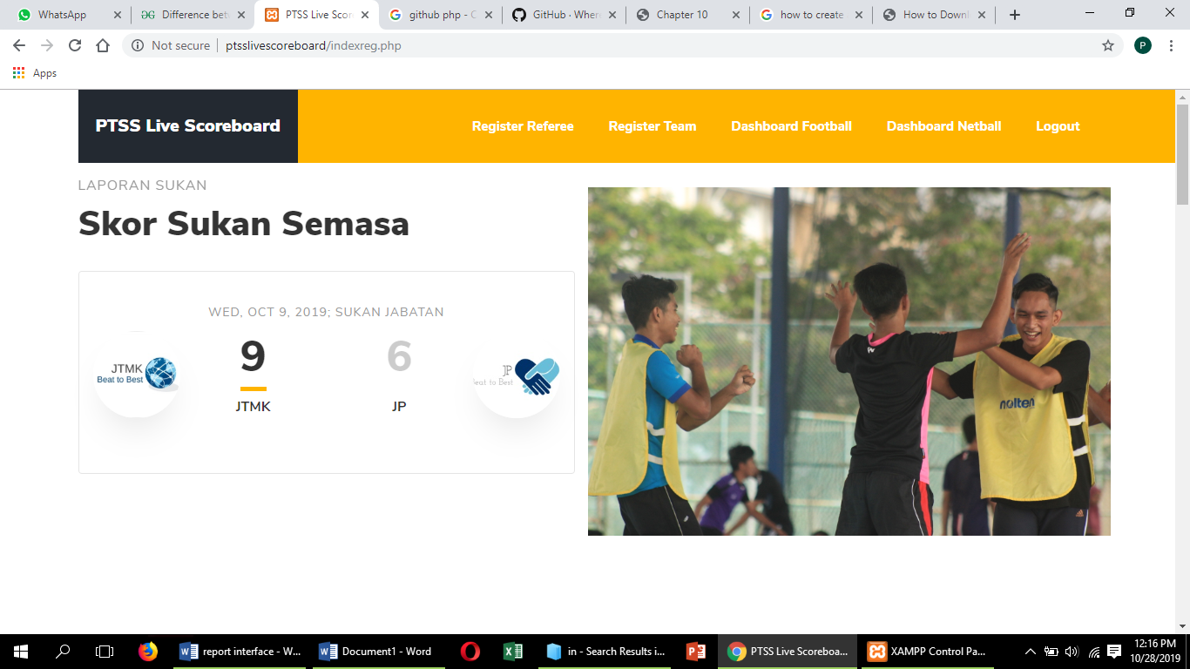

Figure 4 Page home

This is Home page after sport officer login.

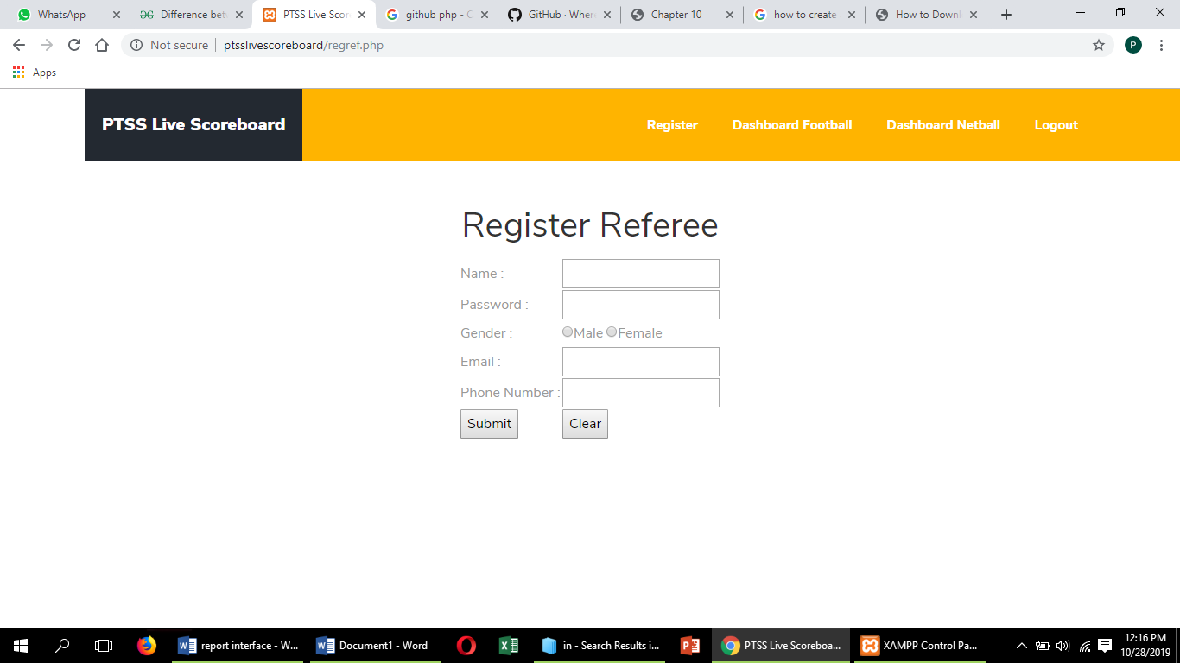

Figure 5 Interface register referee

This is interface register referee after click button register referee.

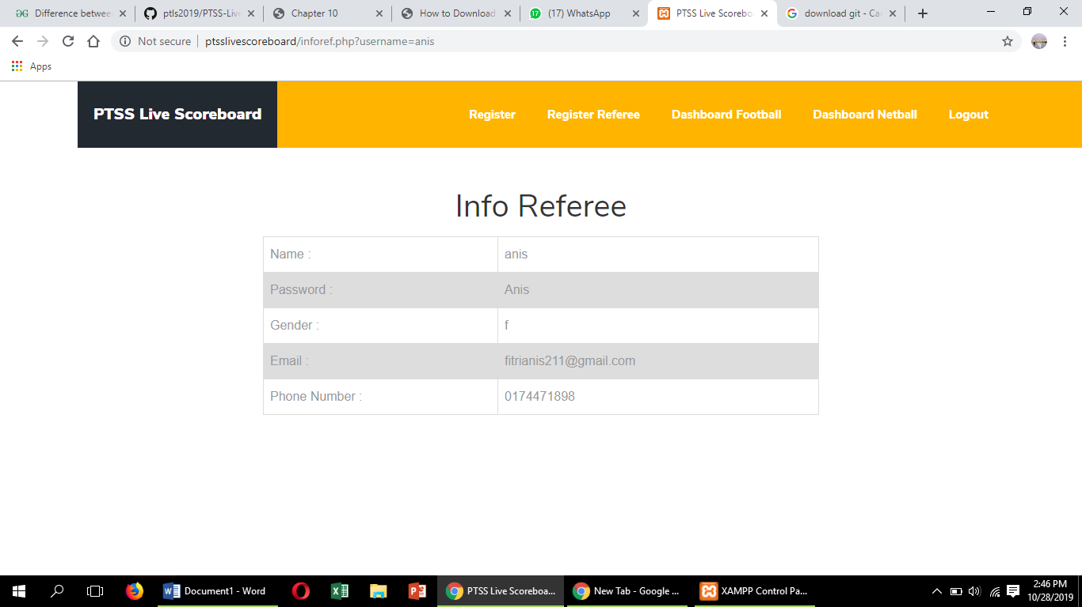

Figure 6 This is view information.



After click on submit button, it will directly go to Home page that is designed for Sport Officer.

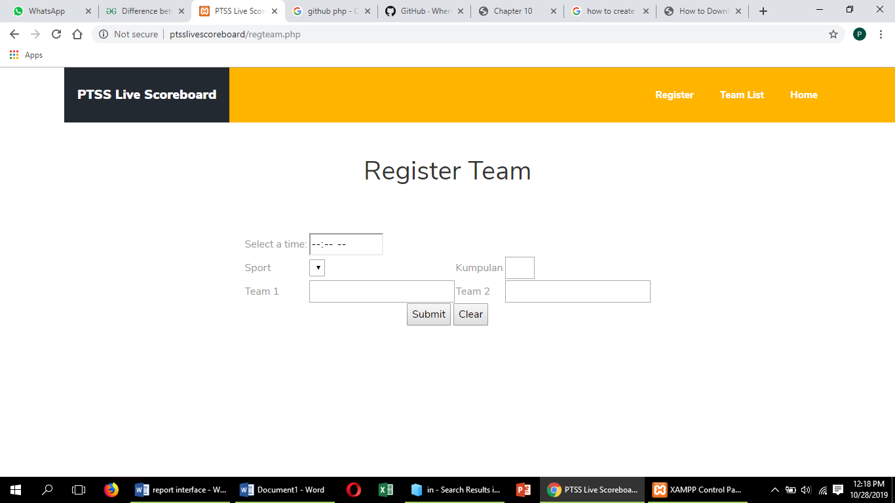

Figure 7 This is register team interface

Click on register team button for register team and then click submit button.

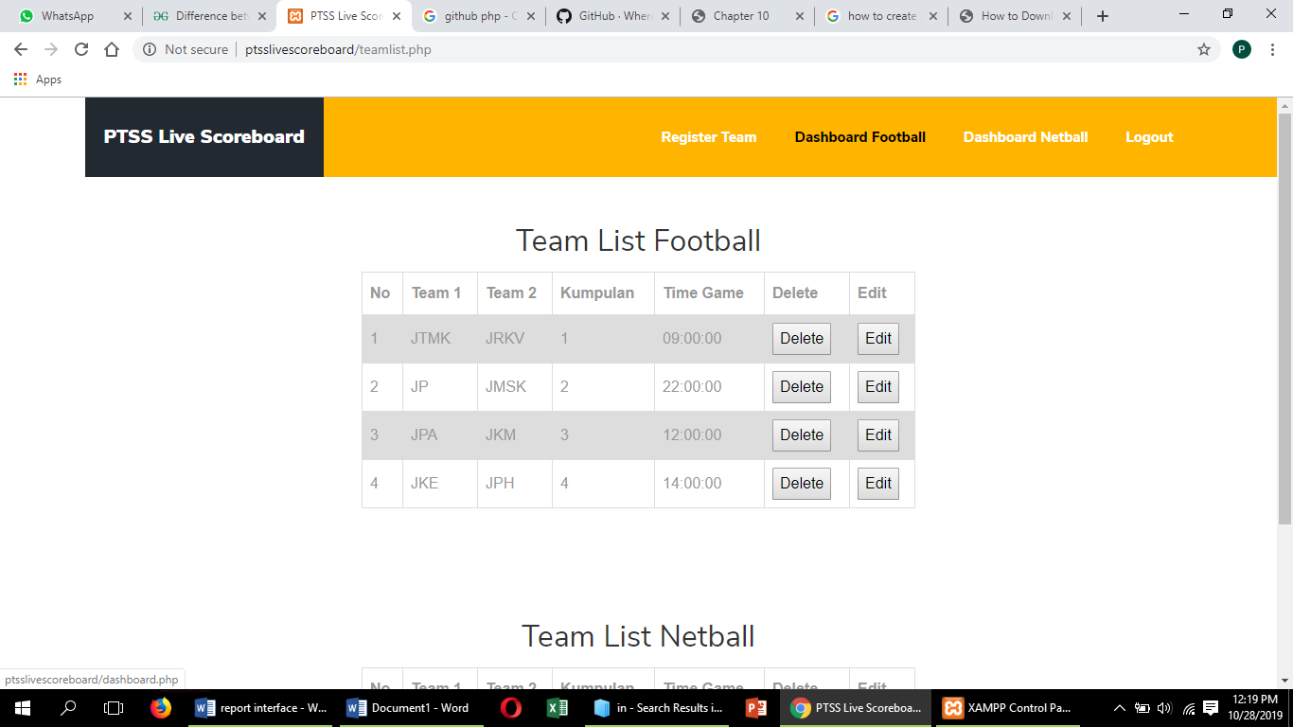

Figure 8 This is interface team list

After that, click on team list button. Then, go to dashboard football to view the display of scoreboard.

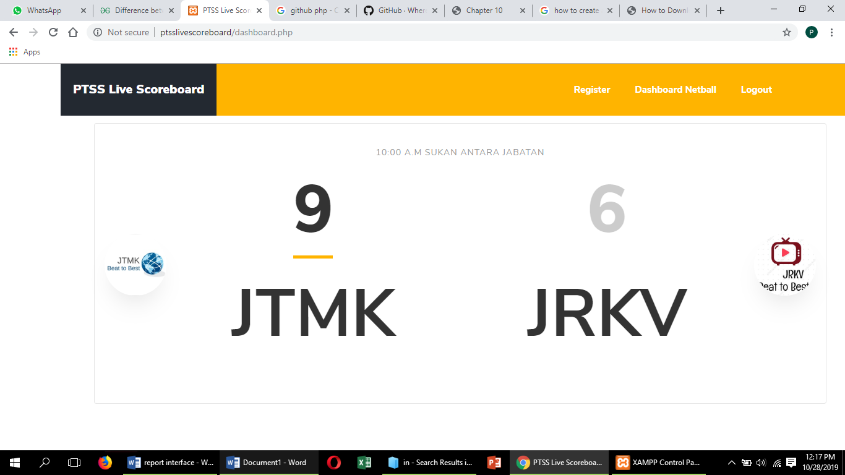

Figure 9 This is dashboard football interface.

Login as a Referee.



Figure 10 Login as a referee interface.

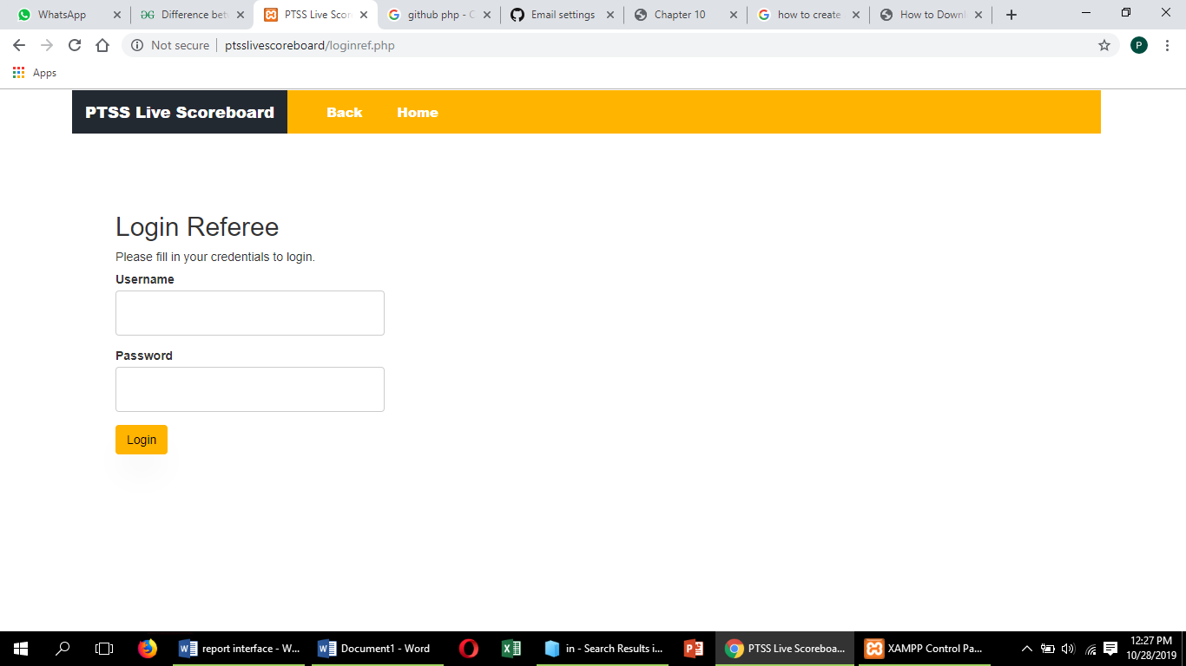

Figure 11 Login referee interface

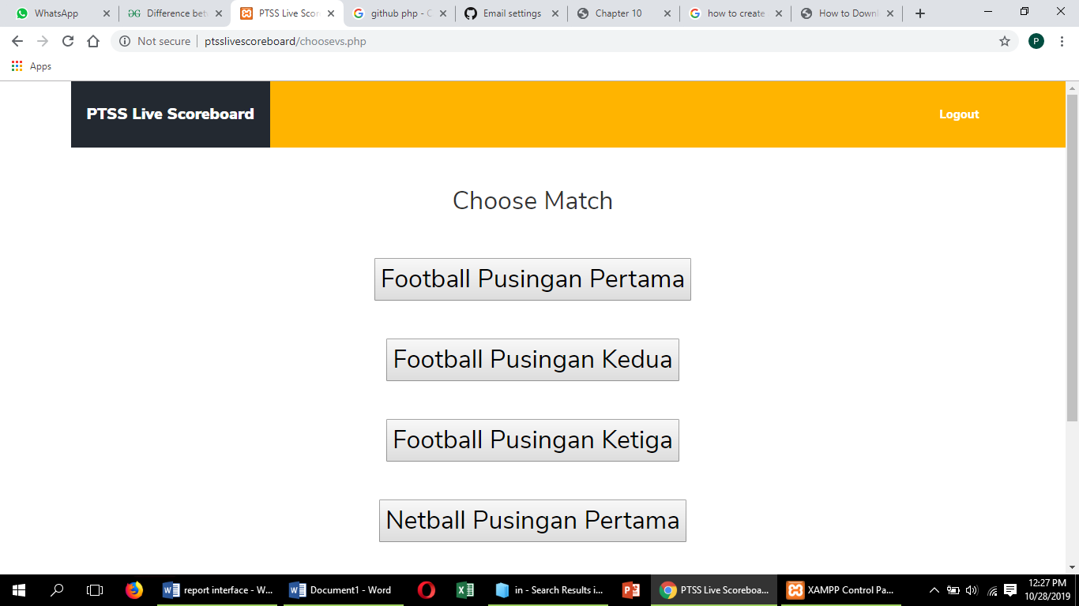

Figure 12 This is choose match interface.

After click on login button, it will directly go to choose match that is designed for Referee.

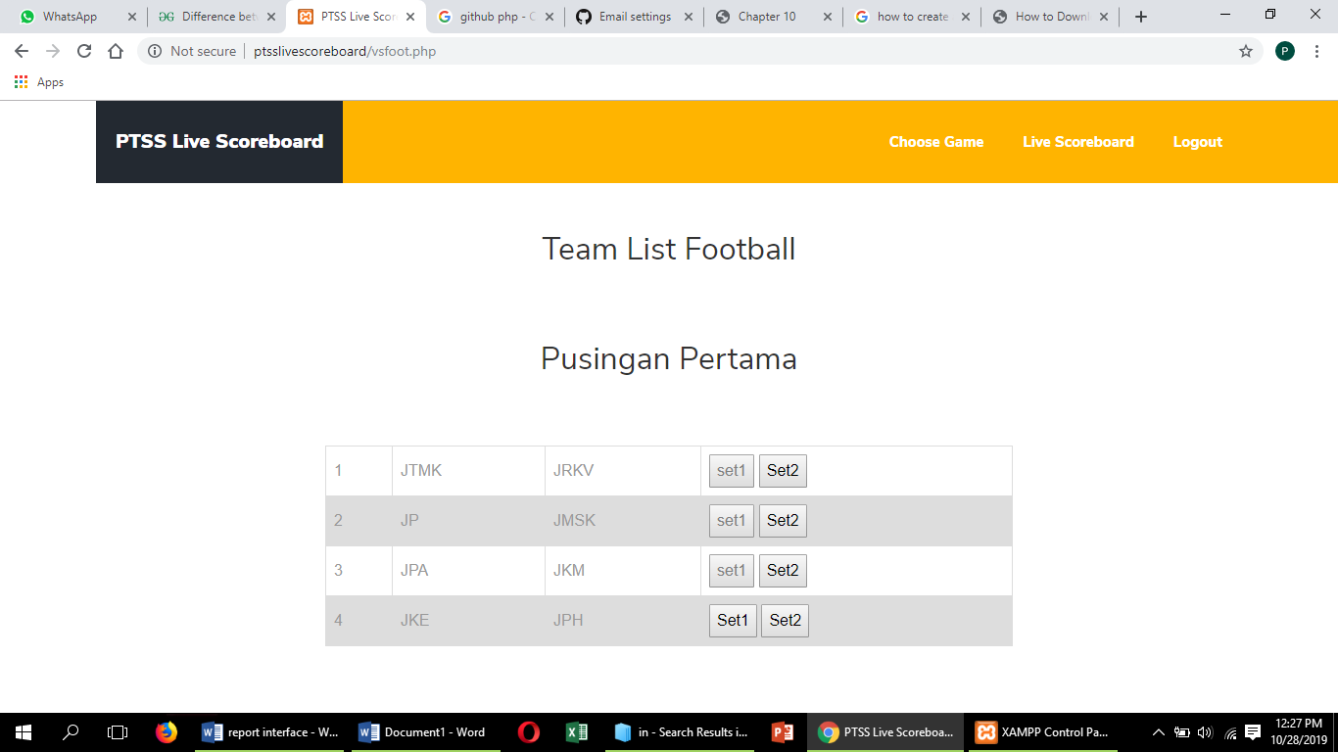

Figure 13 This is choose set 1 interface.

Click on set 1 button for the first round.

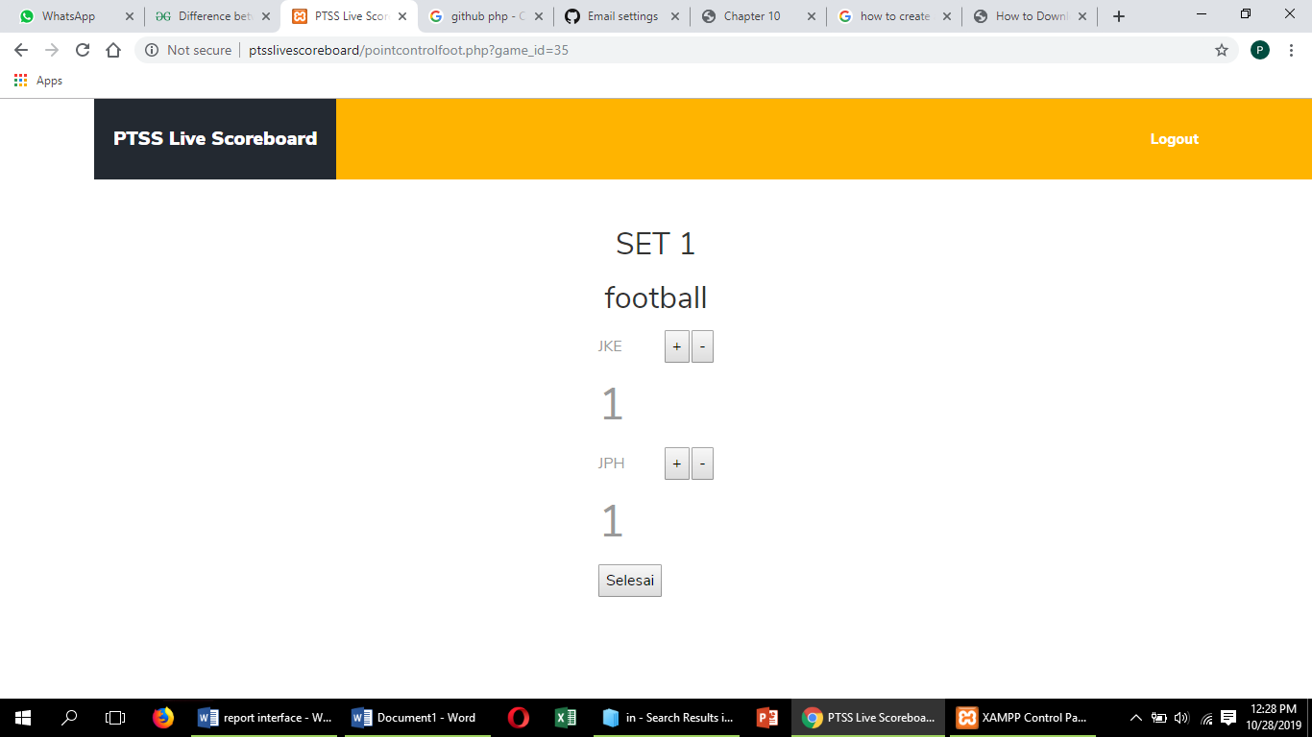

Figure 14 This is set 1 interface.

Click on “selesai” button and it will directly go to choose set for game second round.

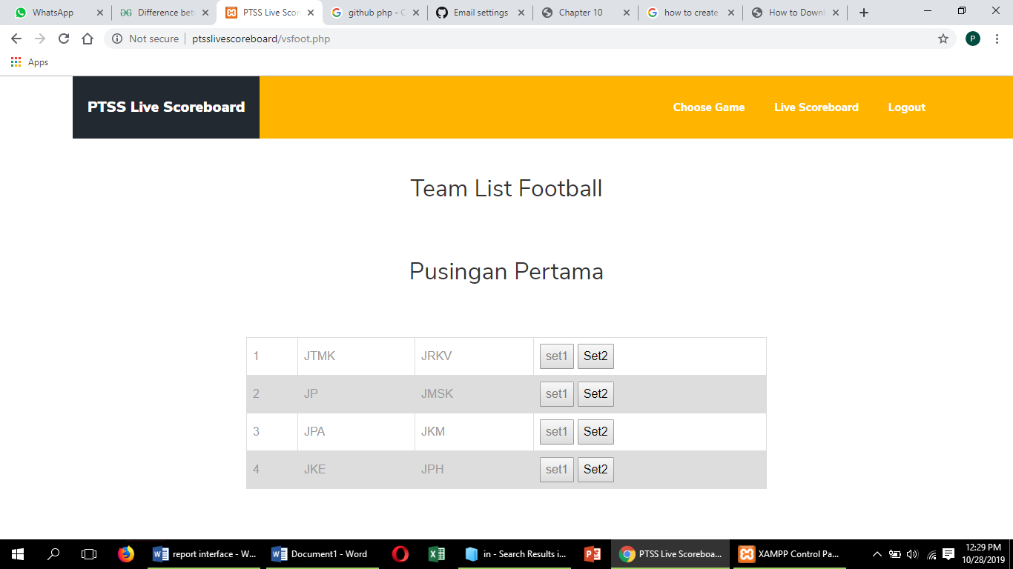

Figure 15 This is choose set 2 interface.

Click on set 2 for the second round.

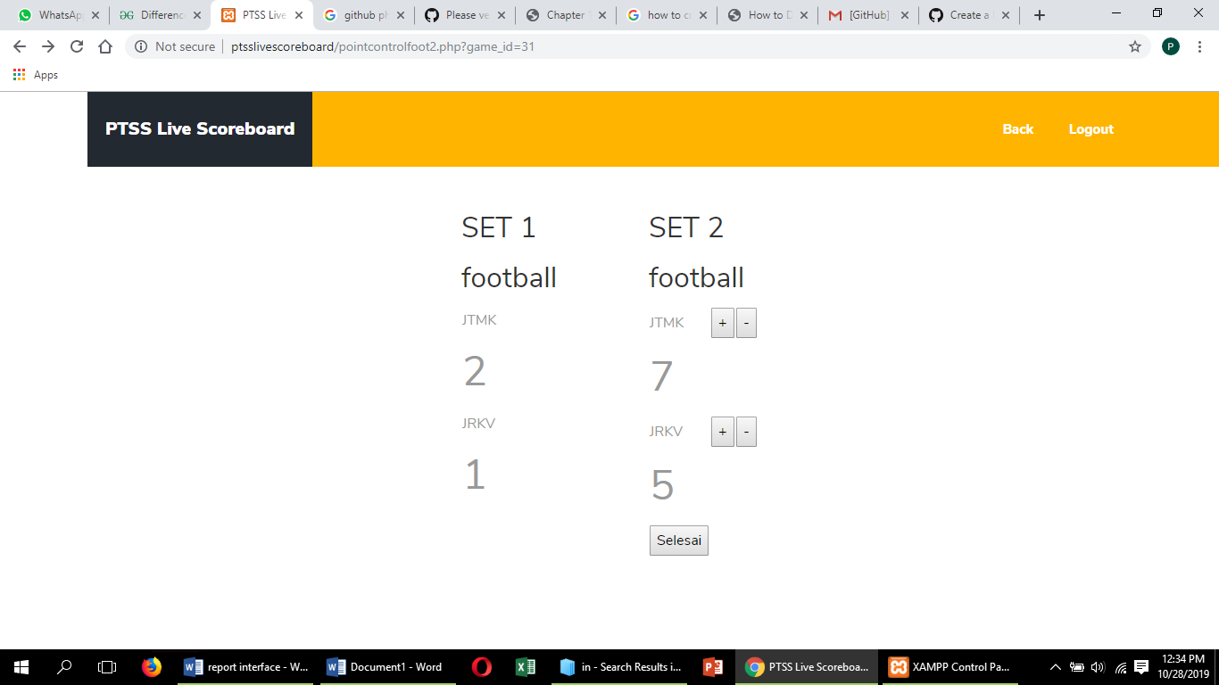

Figure 16 This is set 2 interface

Click on “selesai” button, it will directly go to choose set for next game.

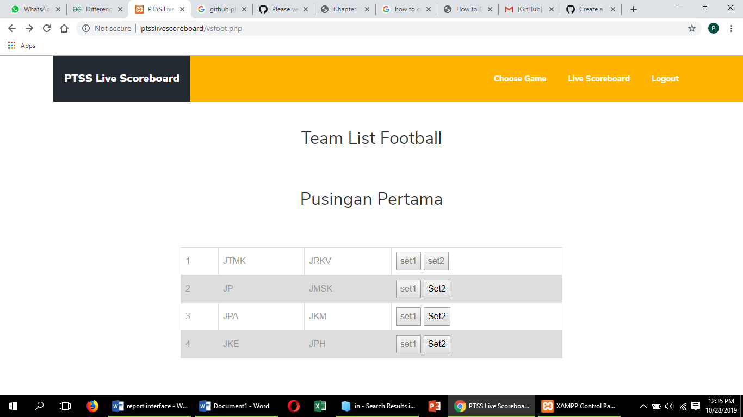

Figure 17 This is choose set interface.

Click on choose game button for next game.

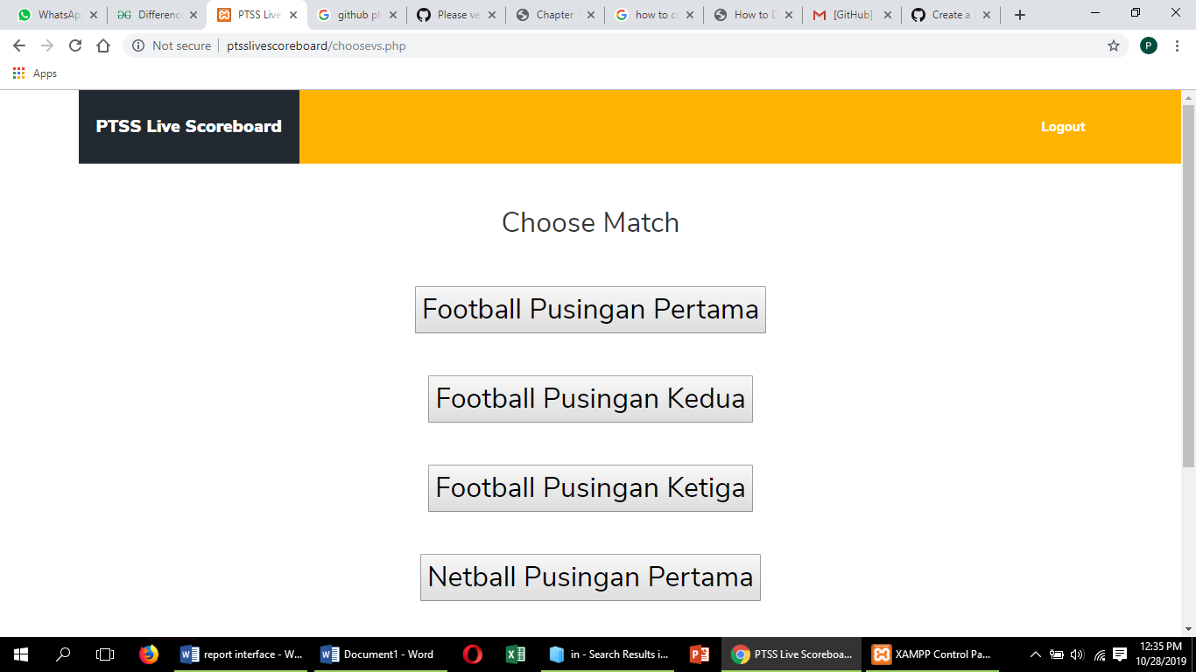

Figure 18 This is choose match interface.

**Viewer**



Figure 19 This is Home page.

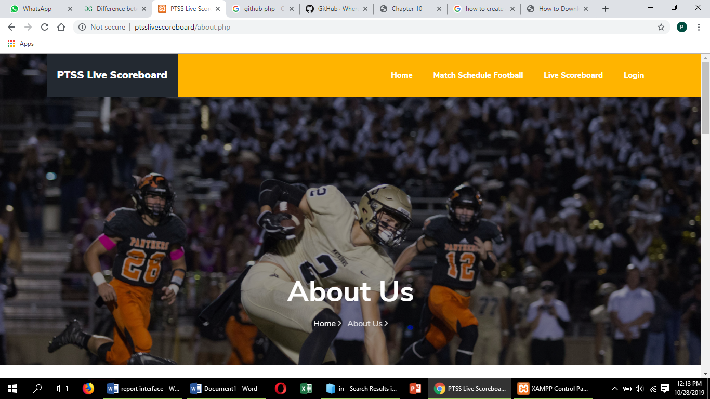

Figure 20 This is About interface.

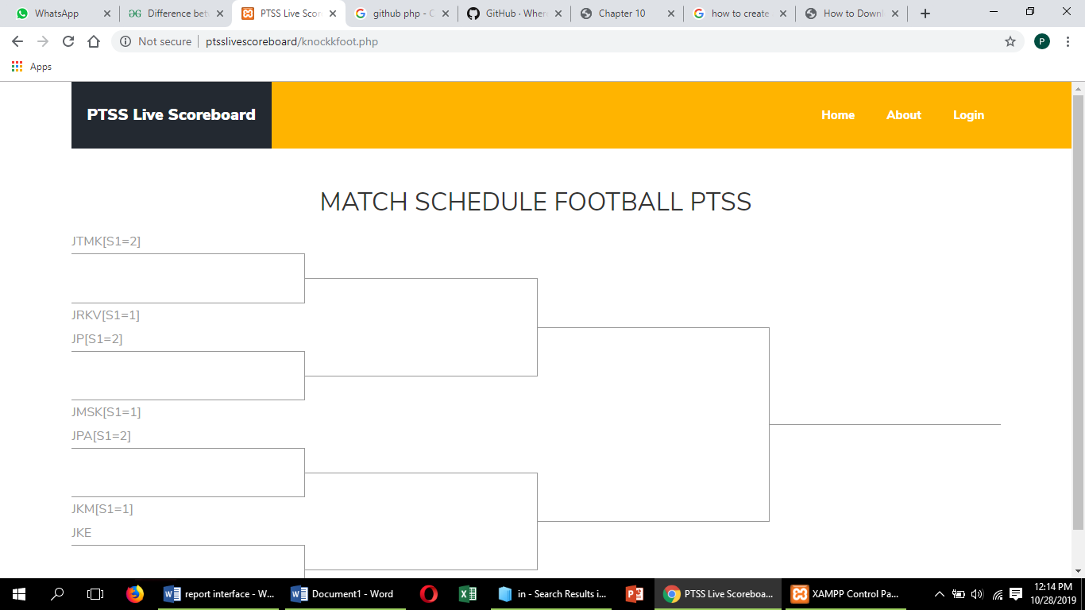

Figure 21 This is match schedule interface.

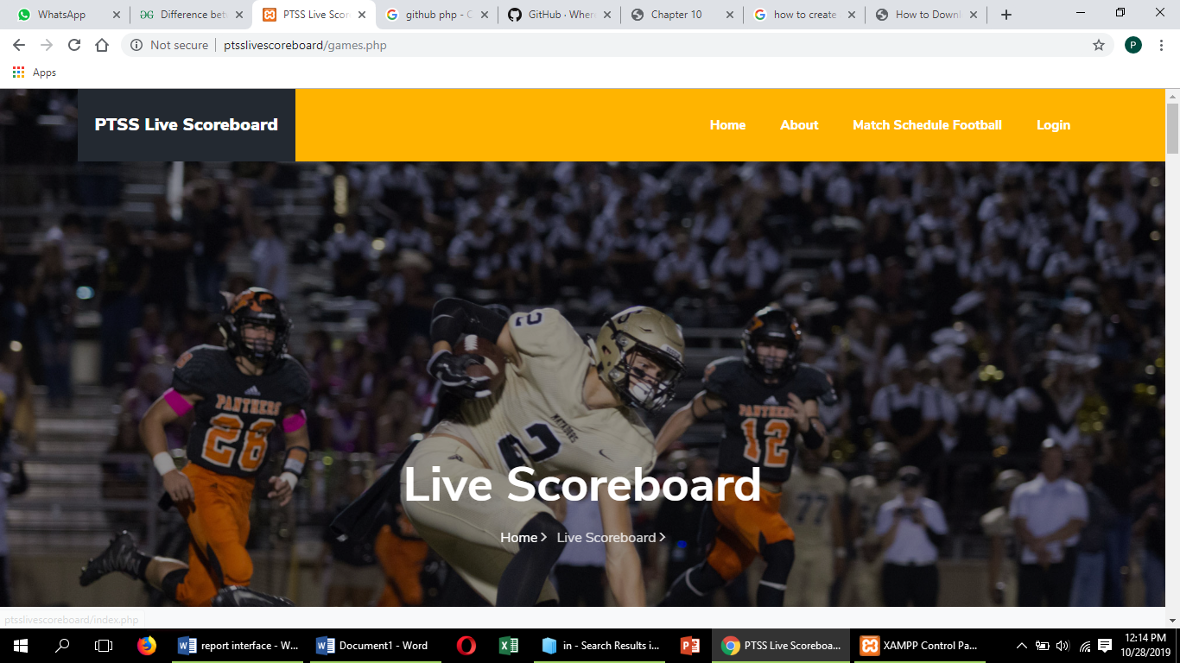

Figure 22 This is PTSS Livescoreboard.